# Filterdesign Boombox

f0 = 2.2kHz

R[E96], C[E24]

## Aktiver Tiefpass

## Low Noise Configuration Low Power Configuration

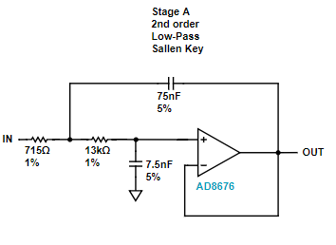 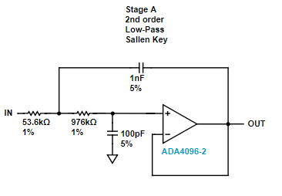

## Aktiver Hochpass

## Low Noise Configuration Low Power Configuration

